SIMATS ENGINEERING
ASSESSMENT TOOL 2

COURSE NAME: Database Management Systems COURSE CODE: CSA0509

COURSE OUTCOME COVERED

CO3: Analyze relational databases using functional dependencies, normalization (1NF to 5NF), and key constraints to identify redundancy and ensure data integrity. (BL2, BL3)

Activity Tool : Case Study (Medium) Assessment Tool Weightage: 30%

QUESTIONS Total Marks: 50
Q.N o | Question | Bloom's Level | Marks
1 | Analyze the case: An online shopping platform stores  Order(OrderID, CustID, CustName, ProdID, ProdName, Qty, Price).  Identify FDs and normalize to 3NF. | BL2 – Understand | 5
2 | A hospital maintains Patient(PID, PName, DocID, DocName, Specialization, WardNo, WardName). Identify anomalies and normalize to BCNF. | BL3 – Apply | 5
3 | Case study: A university stores Enrollment(SID, SName, CourseID, CourseName, Faculty, Grade). Analyze FDs and apply 2NF decomposition. | BL3 – Apply | 5
4 | Given the airline booking case: Booking(FlightNo, PassID,  PassName, Seat, DeptCity, ArrCity, Date). Normalize up to BCNF. | BL3 – Apply | 5
5 | Analyze an HR system schema for a multinational company. Identify all functional and transitive dependencies and normalize to 3NF. | BL2 – Understand | 5
6 | Case: Library(MemberID, MemberName, BookID, Title, Author, Genre, BorrowDate). Identify MVDs and decompose to 4NF. | BL3 – Apply | 5

7 | Analyze a telecom billing schema and identify all candidate keys, primary keys, and functional dependencies before normalization. | BL2 – Understand | 5
8 | A retail inventory system has Product(PID, PName, SupplierID, SupplierName, Category, Price, Warehouse). Apply complete normalization. | BL3 – Apply | 5
9 | Study the given poorly normalized schema for a School ERP and propose a fully normalized design up to BCNF with justification. | BL3 – Apply | 5
10 | Given a movie streaming platform schema, identify join dependencies and decompose to 5NF with lossless-join verification. | BL3 – Apply | 5

Code of Conduct:

I JEROLD SAMUEL J (192571052) (Name / Reg No) certify that this
submission is my original work and that I have adhered to the guidelines specified for this assessment. I understand that any violation of academic integrity rules will result in disciplinary action.

Signature of the student:

JEROLD SAMUEL J (192571052)
1. Analyze the case: An online shopping platform stores Order(OrderID, CustID, CustName, ProdID, ProdName, Qty, Price). Identify FDs and normalize to 3NF.

The major functional dependencies are:
- OrderID → CustID, ProdID, Qty
- CustID → CustName
- ProdID → ProdName, Price
Candidate Key = OrderID
➢ 1NF
The relation is already in 1NF because all attributes contain atomic values.
Order(OrderID, CustID, CustName, ProdID, ProdName, Qty, Price) ➢ 2NF
Since the candidate key is a single attribute OrderID, there cannot be a partial dependency. Therefore, the relation is in 2NF. ➢ 3NF Decomposition
There are transitive dependencies: OrderID → CustID → CustName
and
OrderID → ProdID → ProdName, Price Therefore, decompose the relation into:
Customer
Customer(CustID, CustName)
Product
Product(ProdID, ProdName, Price)
Order
Order(OrderID, CustID, ProdID, Qty) ➢ Final Schema
Customer(CustID, CustName)
Product(ProdID, ProdName, Price) Order(OrderID, CustID, ProdID, Qty) Primary Keys:
- Customer → CustID
- Product → ProdID
- Order → OrderID Foreign Keys:
- Order.CustID → Customer.CustID
- Order.ProdID → Product.ProdID

SQL QUERY:

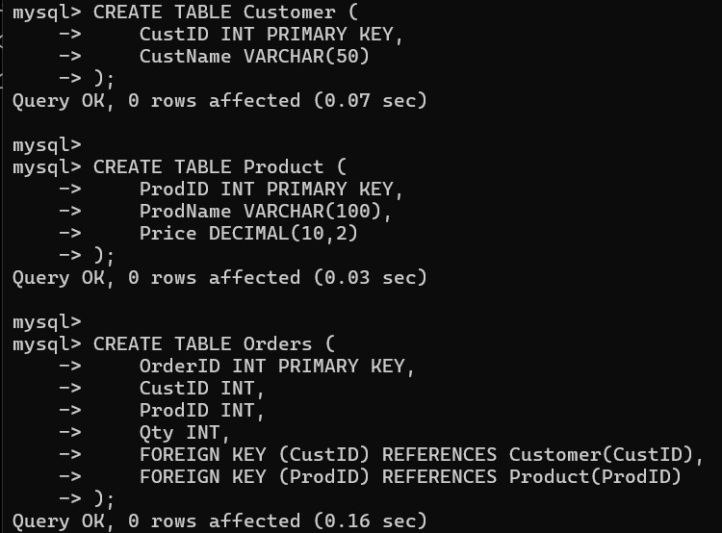

2. A hospital maintains Patient(PID, PName, DocID, DocName, Specialization, WardNo, WardName). Identify anomalies and normalize to BCNF.
The functional dependencies are:
- PID → PName, DocID, WardNo
- DocID → DocName, Specialization
- WardNo → WardName
Candidate Key:
Candidate Key = PID
- Identification of Anomalies
There are transitive dependencies:
PID → DocID → DocName, Specialization
PID → WardNo → WardName
Therefore, storing all attributes in one relation causes redundancy.
- BCNF Decomposition
A relation is in BCNF if for every non-trivial functional dependency:
X → Y
X must be a superkey.
In the original relation:
DocID → DocName, Specialization but DocID is not a superkey.
Similarly:
WardNo → WardName
but WardNo is not a superkey.
Therefore, the relation violates BCNF.
4. Decomposed Relations
Patient
Patient(PID, PName, DocID, WardNo)
Doctor
Doctor(DocID, DocName, Specialization)
Ward
Ward(WardNo, WardName)

SQL QUERY

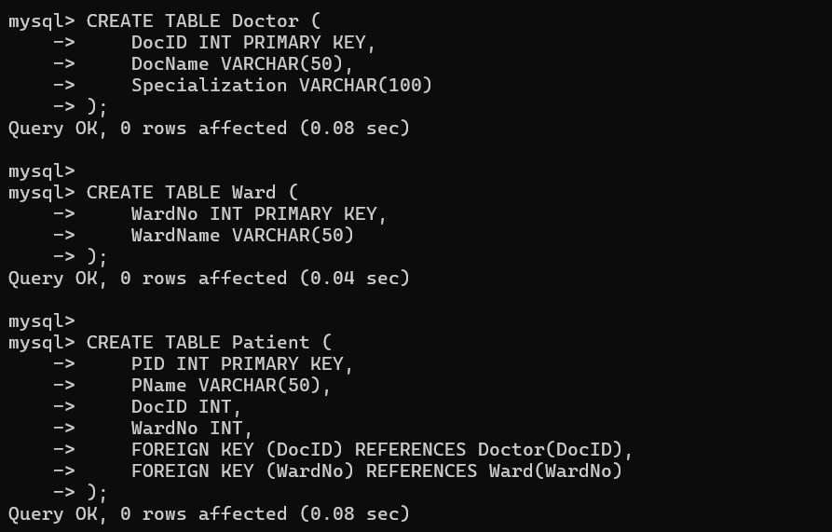
3. Case study: A university stores Enrollment(SID, SName, CourseID, CourseName, Faculty, Grade). Analyze FDs and apply 2NF decomposition.
- Functional Dependencies
The functional dependencies are:
  - SID → SName
  - CourseID → CourseName, Faculty
  - (SID, CourseID) → Grade Candidate Key:
(SID, CourseID)
- 1NF
All attributes are atomic, so the relation is in 1NF.
- 2NF Analysis
The candidate key is composite:
(SID, CourseID) However:
SID → SName
CourseID → CourseName, Faculty
These are partial dependencies because non-key attributes depend on only part of the composite key.
Therefore, the relation is not in 2NF.
- Decomposition into 2NF
Student
Student(SID, SName)
Course
Course(CourseID, CourseName, Faculty)
Enrollment
Enrollment(SID, CourseID, Grade)
SQL QUERY:

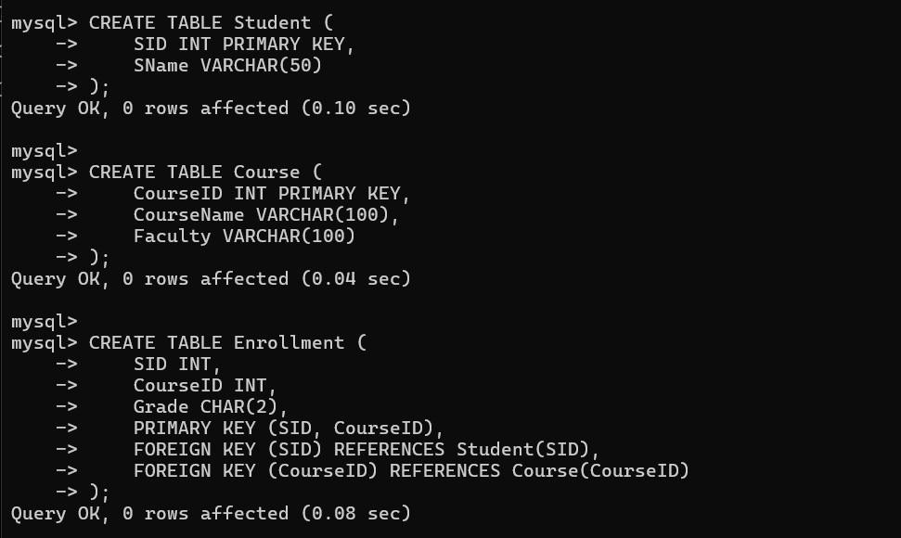
4. Given the airline booking case: Booking(FlightNo, PassID, PassName, Seat, DeptCity, ArrCity, Date). Normalize up to BCNF.
Assuming a passenger can book a particular flight and seat:
  - PassID → PassName
  - FlightNo → DeptCity, ArrCity
  - (FlightNo, PassID) → Seat, Date Candidate Key:
(FlightNo, PassID)
- BCNF Analysis Consider:
PassID → PassName
PassID is not a superkey of the complete Booking relation.
Also:
FlightNo → DeptCity, ArrCity
FlightNo is not a superkey of the complete Booking relation.
Therefore, the relation violates BCNF.
- BCNF Decomposition
Passenger
Passenger(PassID, PassName)
Flight
Flight(FlightNo, DeptCity, ArrCity)
Booking
Booking(FlightNo, PassID, Seat, Date)
SQL QUERY:
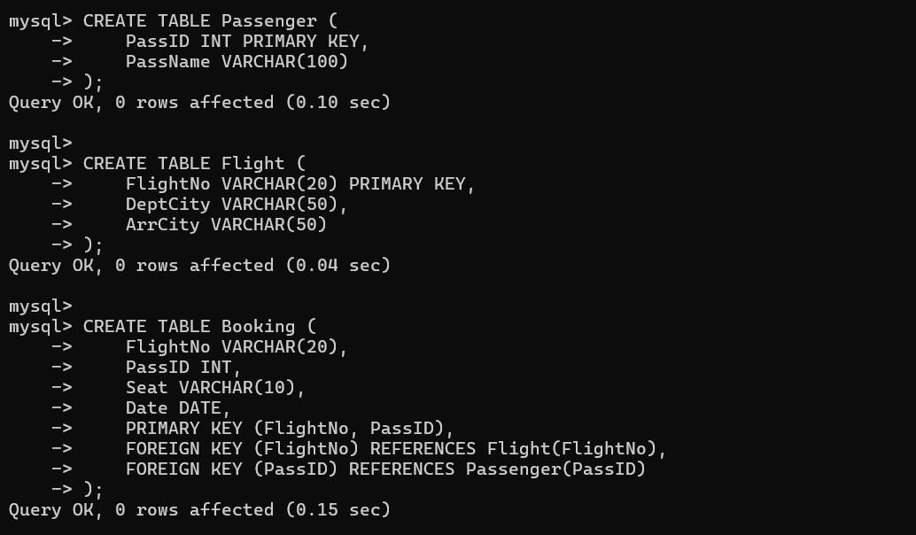

5. Analyze an HR system schema for a multinational company. Identify all functional and transitive dependencies and normalize to 3NF.
The functional dependencies are:
EmpID → EmpName, DeptID, Salary
DeptID → DeptName, ManagerID
ManagerID → ManagerName Candidate Key:
EmpID
- Transitive Dependencies
There are transitive dependencies:
EmpID → DeptID → DeptName
EmpID → DeptID → ManagerID
EmpID → DeptID → ManagerID → ManagerName
Therefore, storing all information together causes redundancy.
- 3NF Decomposition
Employee
Employee(EmpID, EmpName, DeptID, Salary)
Department
Department(DeptID, DeptName, ManagerID)
Manager
Manager(ManagerID, ManagerName)

SQL QUERY:

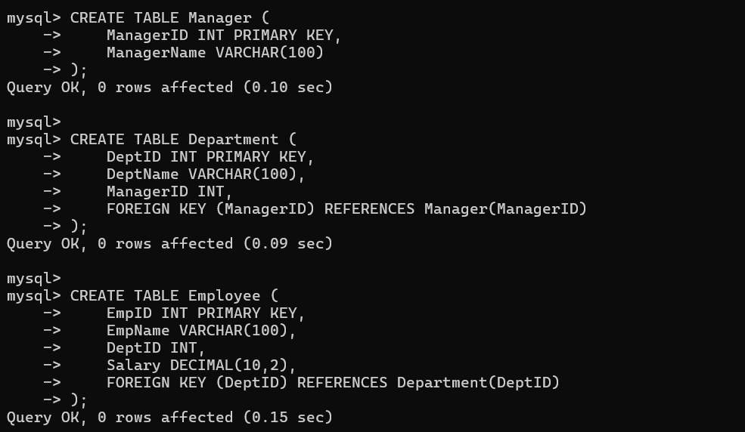
6. Case: Library(MemberID, MemberName, BookID, Title, Author, Genre, BorrowDate). Identify MVDs and decompose to 4NF.
Assume a member can borrow multiple books and a book can have multiple authors.
The following independent multivalued dependencies may exist:
MemberID →→ BookID
BookID →→ Author
The book's title and genre depend on BookID:
BookID → Title, Genre
- Problem
If a member borrows multiple books and each book has multiple authors, combining both independent multivalued facts creates unnecessary combinations.
For example:
Member 1 → Book A
Member 1 → Book B and
Book A → Author X Book A → Author Y can produce redundant combinations.
- Decomposition into 4NF
Member
Member(MemberID, MemberName)
Book
Book(BookID, Title, Genre)
BookAuthor
BookAuthor(BookID, Author)
Borrow
Borrow(MemberID, BookID, BorrowDate)
SQL QUERY:
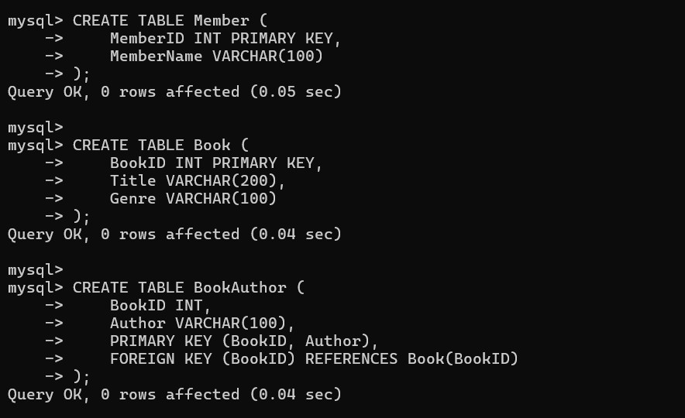

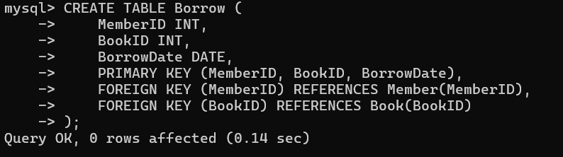

7. Analyze a telecom billing schema and identify all candidate keys, primary keys, and functional dependencies before normalization.
The functional dependencies are:
StudentID → StudentName
CourseID → CourseName, FacultyID
FacultyID → FacultyName
(StudentID, CourseID) → Grade
1. Candidate Key To determine all attributes:
From:
StudentID → StudentName
CourseID → CourseName, FacultyID
FacultyID → FacultyName and:
(StudentID, CourseID) → Grade we obtain:
(StudentID, CourseID)+ which gives: StudentID
StudentName
CourseID
CourseName
FacultyID
FacultyName
Grade
Therefore:
Candidate Key = (StudentID, CourseID)
- Primary Key
The composite candidate key can be selected as the primary key:
PRIMARY KEY(StudentID, CourseID)
- Prime Attributes
The prime attributes are:
StudentID
CourseID
The remaining attributes are non-prime attributes.

SQL

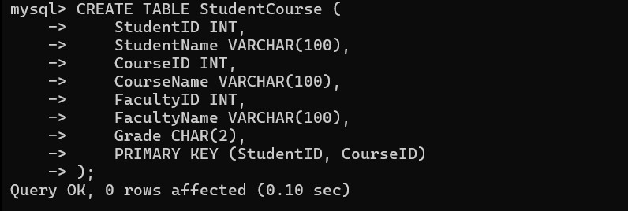

8. A retail inventory system has Product(PID, PName, SupplierID, SupplierName, Category, Price, Warehouse). Apply complete normalisation.
PID → PName, SupplierID, Category, Price, Warehouse
SupplierID → SupplierName Candidate Key:
PID

- Normalization Analysis The dependency:
SupplierID → SupplierName creates a transitive dependency:
PID → SupplierID → SupplierName
Therefore, the original relation is not in 3NF.

- Decomposition
Supplier
Supplier(SupplierID, SupplierName)
Product
Product(PID, PName, SupplierID, Category, Price, Warehouse)
SQL QUERY:
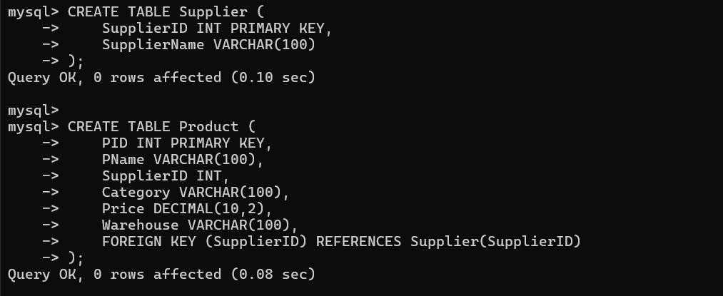

9. Study the given poorly normalized schema for a School ERP and propose a fully normalized design up to BCNF with justification.Poorly Normalized Relation The dependencies are:
StudentID → StudentName, ClassID
ClassID → ClassName, TeacherID
TeacherID → TeacherName
SubjectID → SubjectName
(StudentID, SubjectID) → Marks Candidate Key:
(StudentID, SubjectID)
- Problems in the Original Relation There are partial dependencies:
StudentID → StudentName, ClassID
SubjectID → SubjectName
There are also transitive dependencies:
StudentID → ClassID → ClassName
StudentID → ClassID → TeacherID → TeacherName Therefore, the relation is not in 2NF or 3NF.
- BCNF Decomposition
Student
Student(StudentID, StudentName, ClassID)
Class
Class(ClassID, ClassName, TeacherID)
Teacher
Teacher(TeacherID, TeacherName)
Subject
Subject(SubjectID, SubjectName)
Marks
Marks(StudentID, SubjectID, Marks)

SQL QUERY:
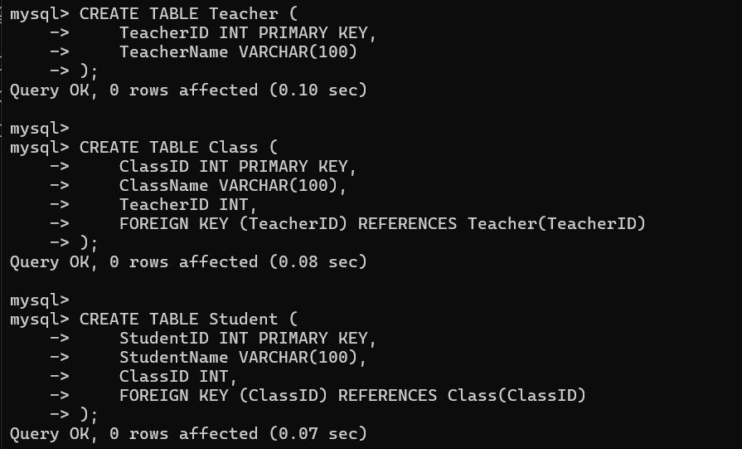

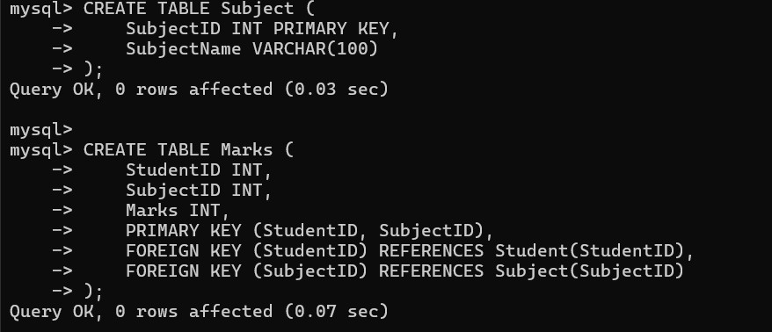

10. Given a movie streaming platform schema, identify join dependencies and decompose to 5NF with lossless-join verification. Given Schema
- Multivalued Dependencies
The following multivalued dependencies exist:
MovieID →→ ActorID
MovieID →→ GenreID
This means that actors and genres are independently associated with a movie.
- Problem with the Relation Suppose:
Movie M1
Actors: A1, A2
Genres: G1, G2
The combined relation may require:
M1 A1 G1
M1 A1 G2
M1 A2 G1
M1 A2 G2
This creates redundant combinations.
- Decomposition
Separate the independent relationships:
Movie
Movie(MovieID, MovieName)
Actor
Actor(ActorID, ActorName)
Genre
Genre(GenreID, GenreName)
MovieActor
MovieActor(MovieID, ActorID)
MovieGenre
MovieGenre(MovieID, GenreID)

SQL QUERY:
